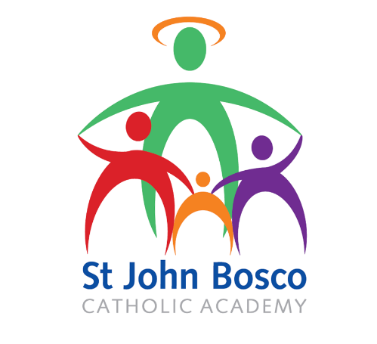

Fair Deal for Job Applicants Statement

The St John Bosco Catholic MAC is committed to recruiting and selecting job applicants fairly. To this end we will make every effort to ensure that you are served by the following standards:
- You will be treated in a polite, helpful and friendly manner at all times.
- We will try to take account of any particular needs you have.
- Whenever we contact you we will give you the name and telephone number of someone who will deal with any queries you may have. We will give you the name of anyone dealing with your telephone enquiry.
- Your application will be dealt with efficiently and confidentially.
- You will be kept informed of any delays that may occur, together with the reasons for them.
- All information provided to you will be written in plain language, accurate and produced to professional standards.
- All decisions will be made on merit and in line with the Job description/Person specification.
- We will take seriously any complaints or concerns you may have about your treatment as a job applicant. We will investigate these promptly and will let you know what we have done.
- Applications are not acknowledged. If we have not contacted you within two weeks of the closing date, you will not have been selected for interview. We will only be able to provide feedback to shortlisted candidates.

